PRESS RELEASE
FOR IMMEDIATE RELEASE

Still Thinking? Get it Moving!
POST-90s REVOLUTION AT HAND

We are going to witness the launch of a brand new Post-90s Revolution, led by a group of 19 ambitious student leaders from the ThinkSeries 2010 Leadership Programme. In a bold attempt to put thoughts into actions, these students will prove themselves to be the prospective global leaders. Instead of passively receiving all the knowledge and experience the trainers offer, the leaders have come up with something big to give to the world in return: to pioneer in a Post-90s Revolution.

Post-90s are no KIDS
Being labelled unfairly with the title of ‘Hong Kong Kids’, the ThinkSeries Leaders, being post-90s themselves, pledge to awake the best in the minds of the post-90s generation. They shall shake off the prevailing misconception of the naive and ignorant post-90s generation, and tell the world that they have much more in store. Their first step is to know what people think about the post-90s. A street interview has been conducted by the leaders, and received many responses.
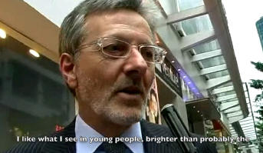
“I like what I see in young people, brighter than probably the previous generation, so I would say, great.” said one of the interviewees.

The street interview has been posted on YouTube, and a Facebook group has been created to invite people to express their views.

Impression of the Post-90s

Street Interview Video: www.youtube.com/watch?v=VFW_gwVoeo8
Facebook Group: www.facebook.com/group.php?gid=361538056038&ref=ts
Leading New Fads
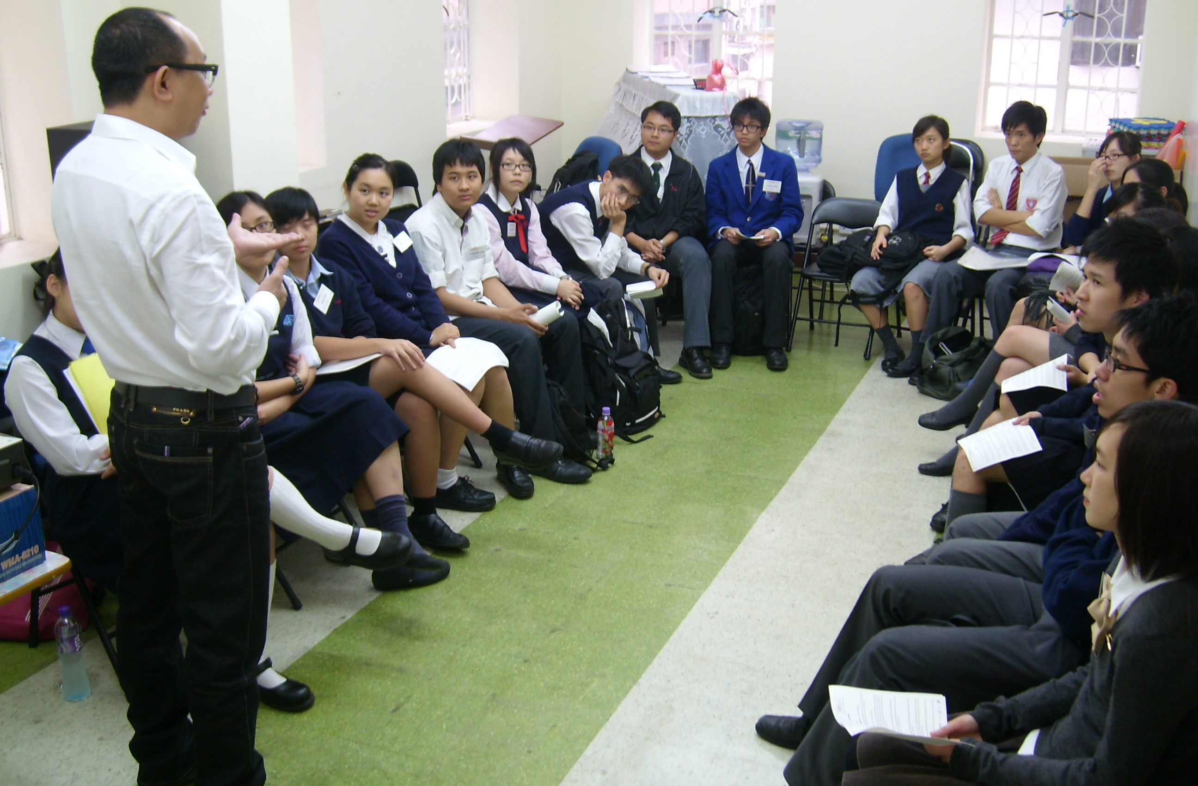
Good leaders lead to serve. Through a series of training sessions and actualisation, the ThinkSeries Leadership Programme has provided these enlightened young minds with a platform to unleash their potentials and to serve the community; and not only to think big, but to act great.

Earlier this year, students from over 70 secondary schools all over Hong Kong were nominated as one of the 19 elite student leaders in the ThinkSeries Leadership Programme, which strives to nurture global perspectives, caring and innovative minds.

For more information, please visit:
www.wiseman.com.hk/site/thinkseries/leadership

You may also contact:

ThinkSeries Leader (S.6)
Hilton Tai Mary Lam
Tel: 9276 0934 (after 4pm) Tel: 6686 8661
Email: leadership@wiseman.com.hk Email: leadership@wiseman.com.hk

Wiseman Education
Winnie Fung
Tel: 3187 4995/ 9323 8589
Email: winnie.fung@wiseman.com.hk
###

PRESS RELEASE ATTACHMENT
ThinkSeries Leaders 2010

Name | School
Chan Jian Kuang, Anthony | Diocesan Boys' School
Cheryl, Chan Cheuk Yu | PLK Mrs Ma Kam Ming Cheung Fook Sien College
Chu Tinki, Judy | Yew Chung International School (Hong Kong)
Fung Peng Kim, Frederick | Creative Secondary School
Isaac Ho | Tsuen Wan Government Secondary School
Vivien Ko | Diocesan Girls' School
Lai Jing Kei, Jackie | Maryknoll Convent School (Secondary Section)
Lam Ching Yin Mary | St Paul's Secondary School
Lam Leung Sang, Andrew | Wah Yan College, Hong Kong
Lam Hiu Ming, Annie | Po Leung Kuk 1984 College
Lee Ka Yee, Rosa | St Francis' Canossian College
Lee Tsun Wai, Angus | Hong Kong Chinese Women's Club College
Leung Long Fung | STFA Leung Kau Kui College
Raphael, Ngai Tsz Fung | Sing Yin Secondary School
Smith Stephanie | HKUGA College
Tai Hiu Tung, Hilton | St Paul's Secondary School
Wu Tsz Wai | Diocesan Girls' School
Yu Wai Yan, Annie | St Mary's Canossian College
Yuen Kin Hang, Tom | Wan Yan College, Kowloon

For more information, please visit:
www.wiseman.com.hk/site/thinkseries/leadership

